**Institute of Computer Technology**

**B. Tech. Computer Science and Engineering**

**Sub: ESFP – I**

**Assignment-1**

**Answer the following questions:**

1. What are Tokens? Explain various kinds of tokens in c programming language?

Ans:

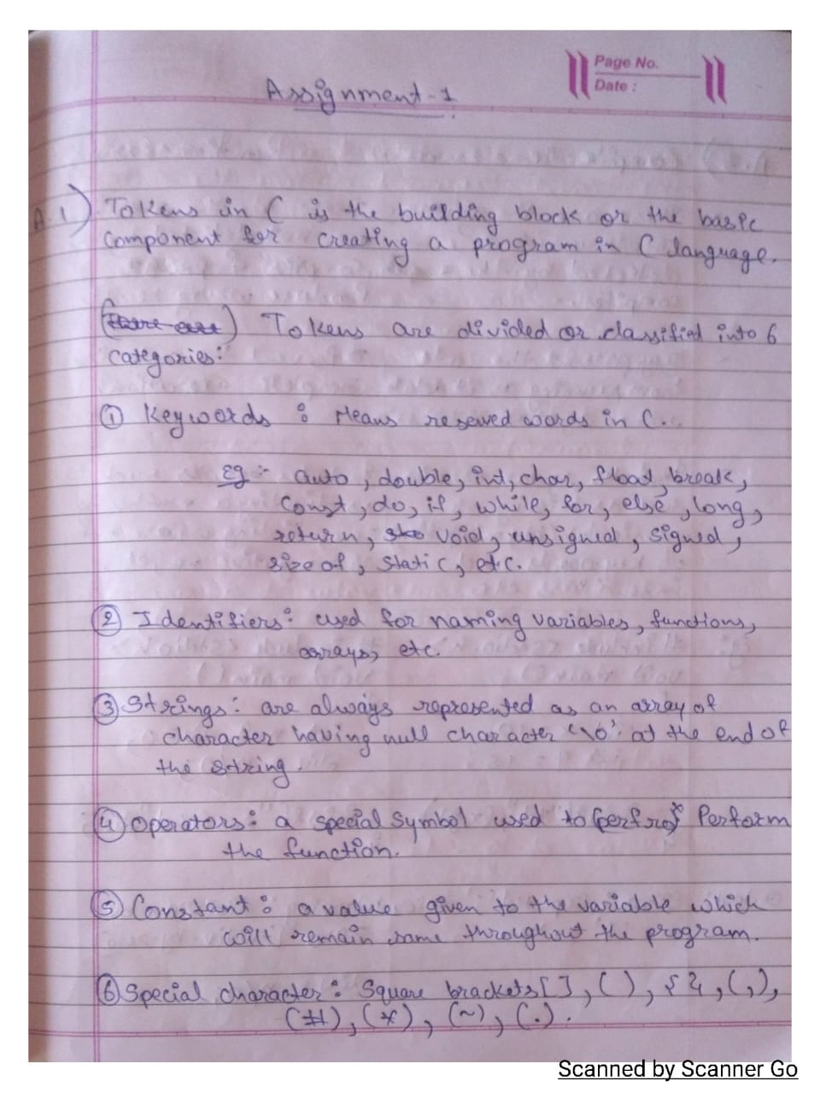

2. Explain the differences between compile time and run time errors with the help examples?

Ans:

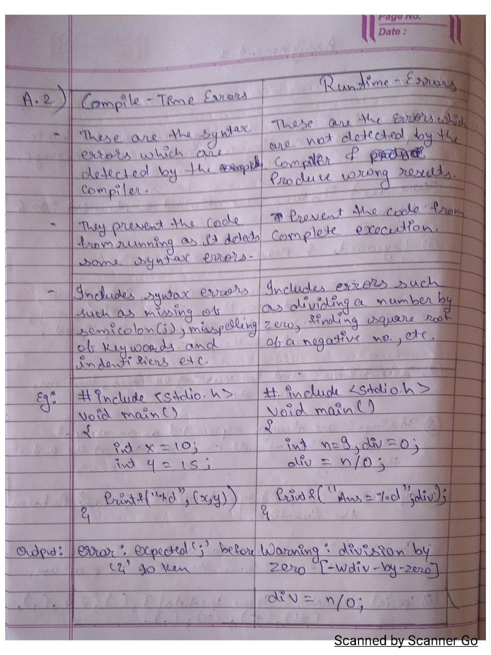

3.Explain different types of data types in C with a suitable program example.

Ans:

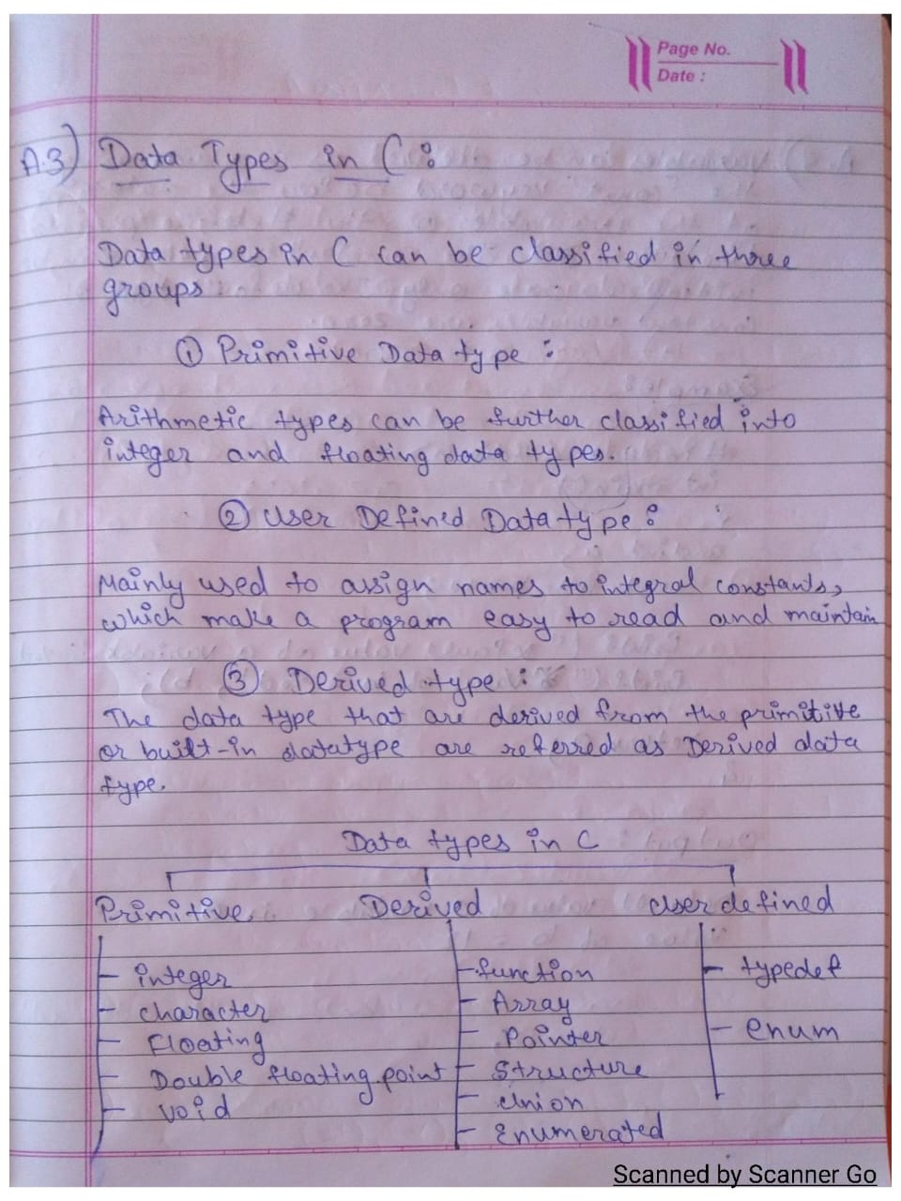

4. Which variables below are syntactically correct?

Ans:

* Num_var
* var1 var2
* v2
* i

5. What will happen if a variable is declared as constant? Give a program example for constant variable declaration.

Ans:

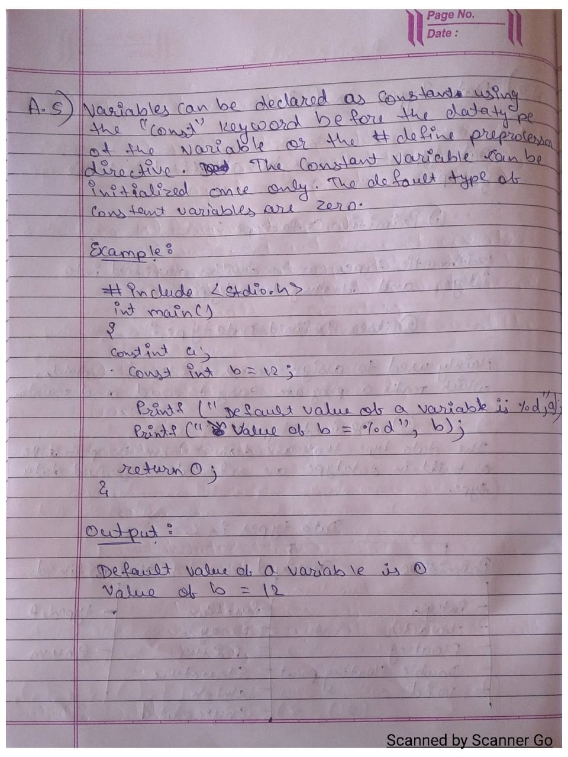

6. Write an algorithm that allows for the input of a character value, prints its ascii code and displays whether it is alphabet or digit?

Ans:

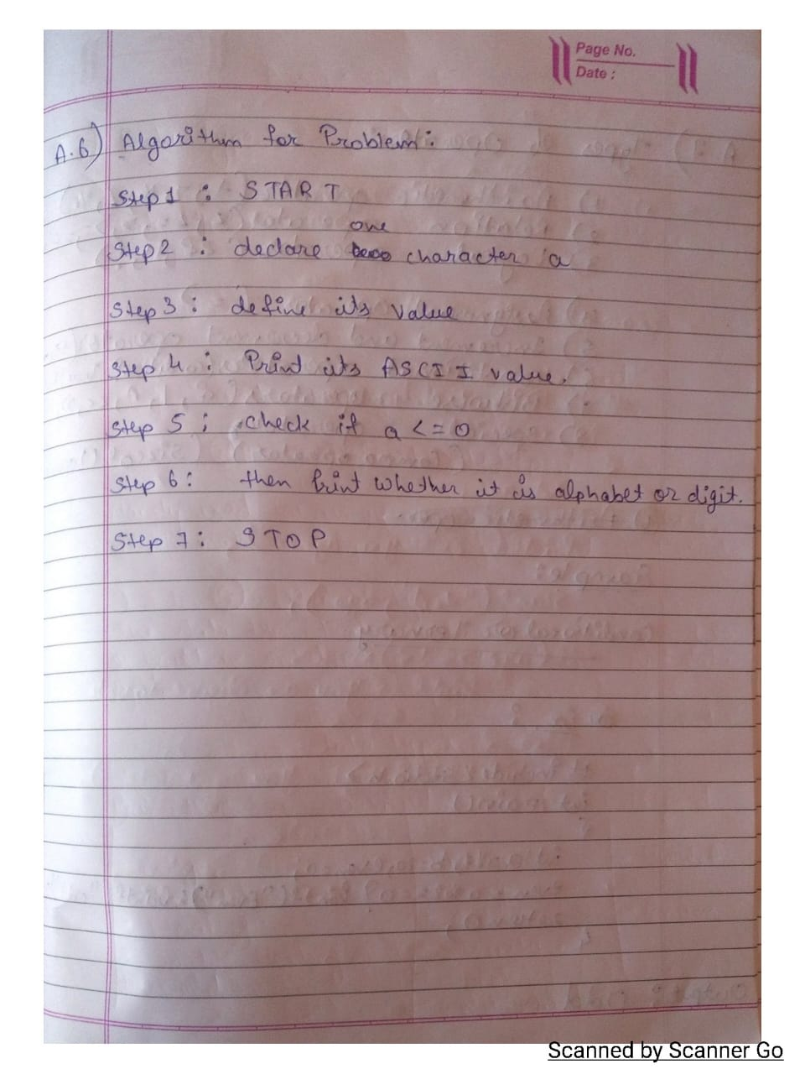

7. Explain different types of operators in C with suitable program examples?

Ans:

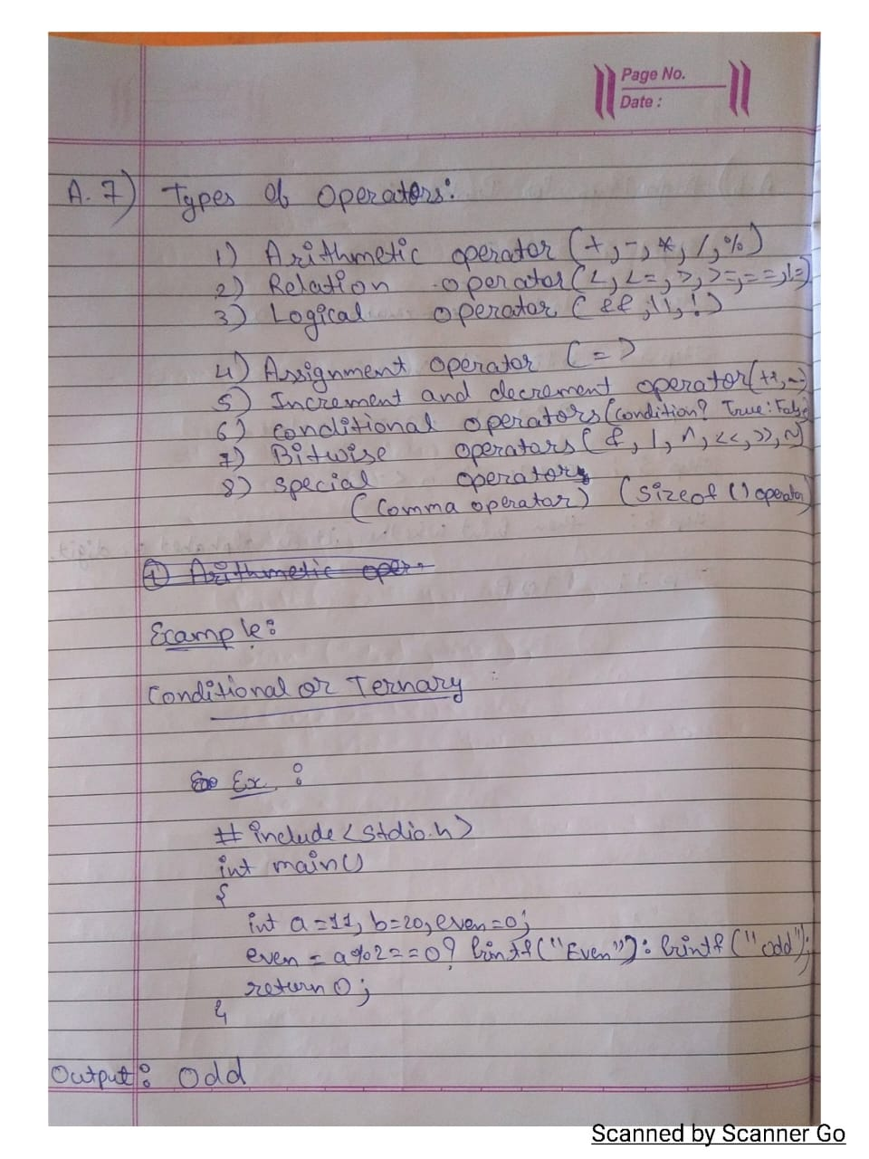

8. Explain the concept if, if – else, nested if – else and else if ladder condition in c with the help of program example.

Ans:

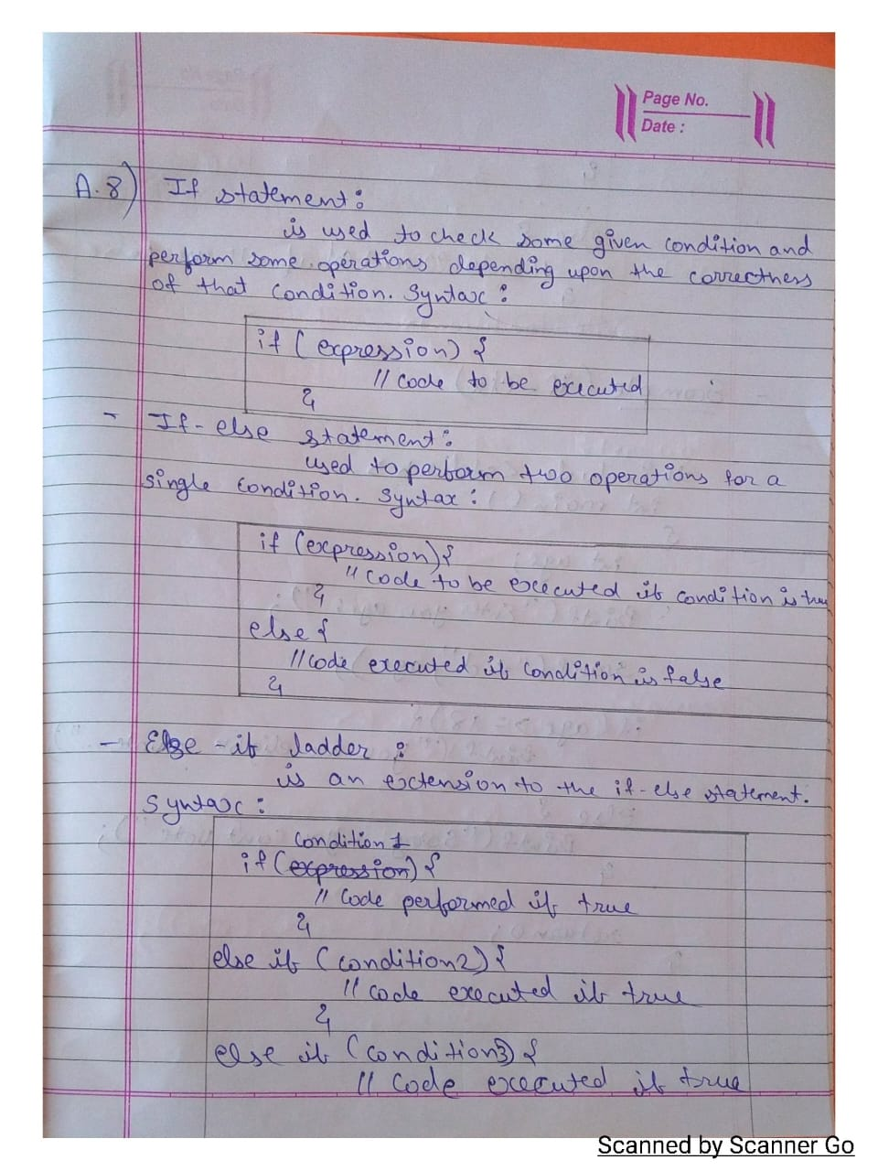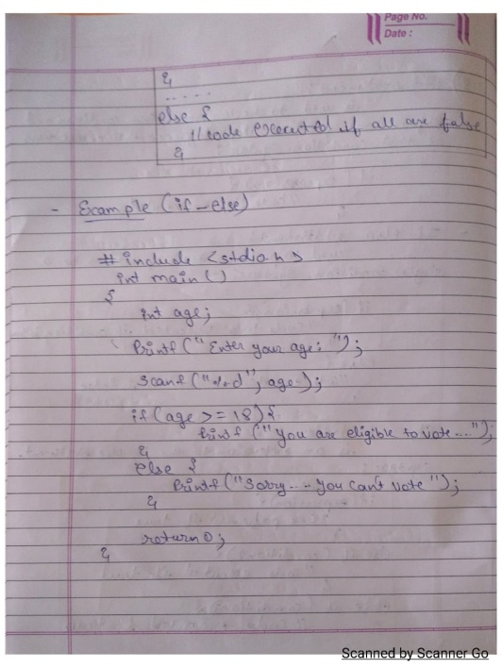

9. What are the classifications of loops? Explain with the help of syntax, flowchart, and suitable program examples?

Ans:

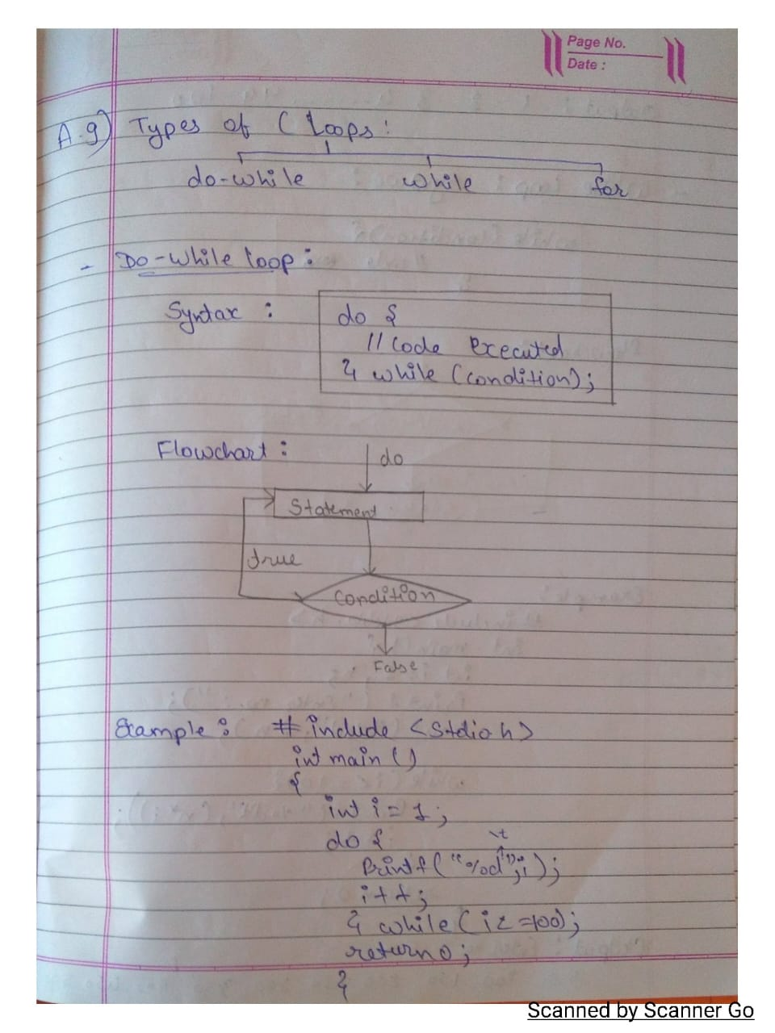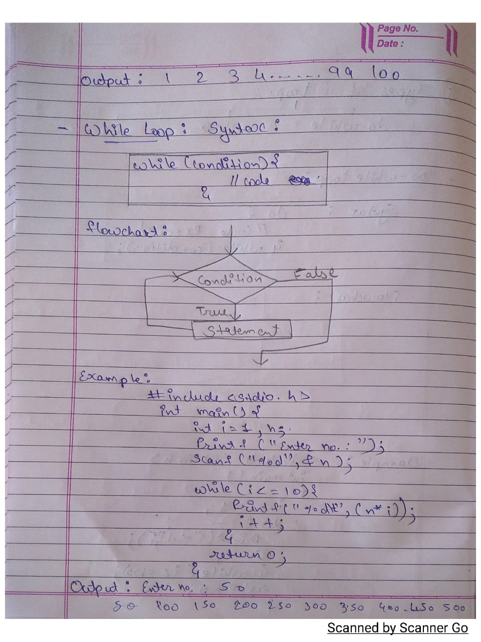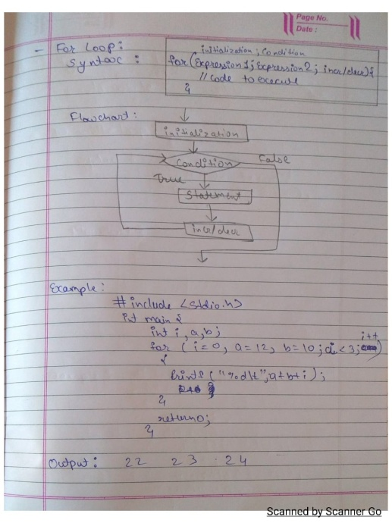

**Find Outputs of following programs:**

1.

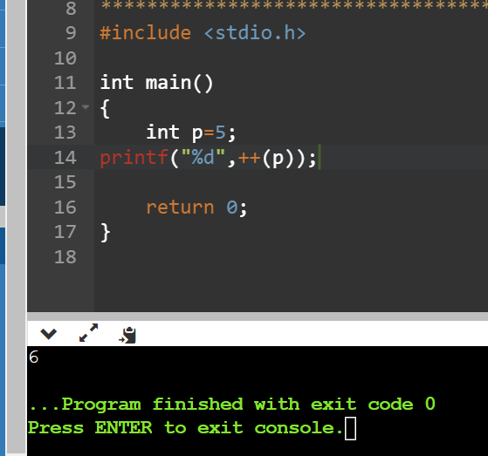

2.

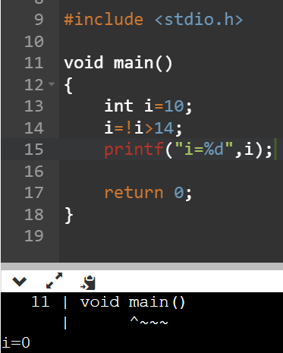

3.

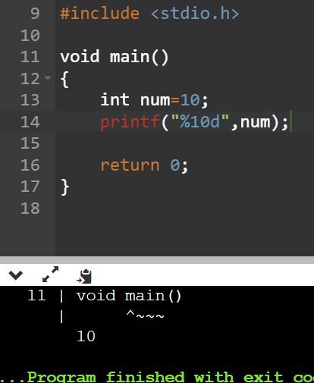

4.

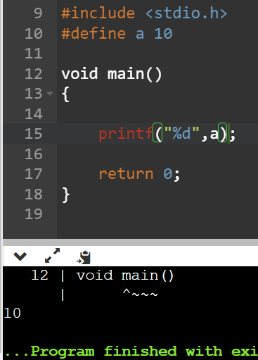

5.

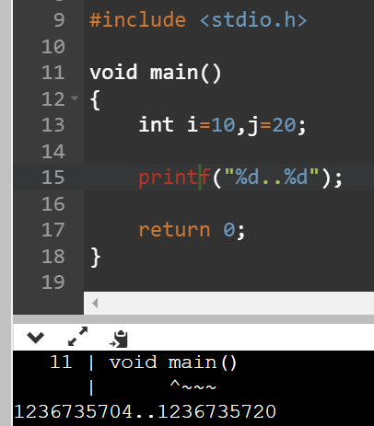

6.

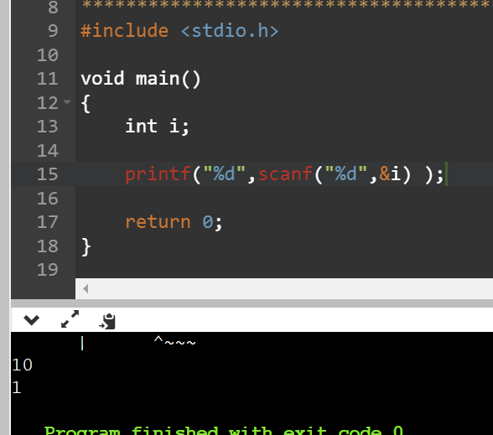

7.

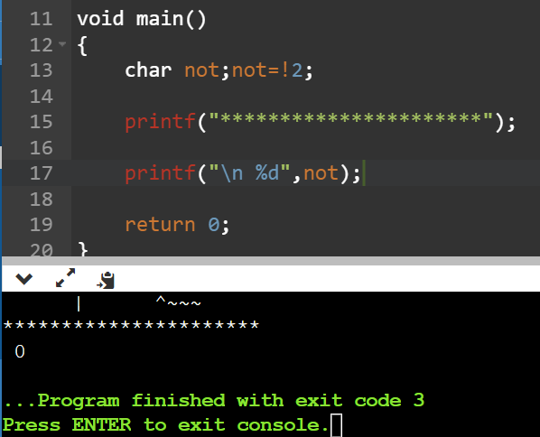

**Programming Exercises**

➢ Write the entire C program code for the questions given below:

1. Make a C program to check least among three integers using Ternary Operator?

Codes:

#include <stdio.h>

int main()

{

int num1,num2,num3;

printf("enter your number:");

scanf("%d %d %d",&num1,&num2,&num3);

int temp=((num1<num2)? num1:num2);

int result=num3<temp?num3:temp;

printf("\n The Smallest number is %d ",result);

getch();

return 0;

}

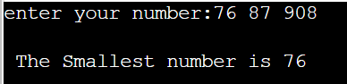

2. Make a C Program to find whether a number is: -

a) Perfect Number.

Codes:

#include <stdio.h>

int main()

{

int n;

printf("Enter the number: ");

scanf("%d",&n);

int sum = 0;

for(int i = 1; i < (n-1); i++)

{

if((n%i)==0){

sum=sum+i;

}

}

if(sum==n){

printf("\n%d is perfect number",n);

}

return 0;

}

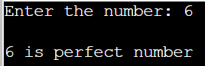

b) Prime Number

Codes:

#include <stdio.h>

int main()

{

int n;

printf("Enter the number: ");

scanf("%d",&n);

int count = 0;

for(int i = 2; i < n; i++)

{

if(n % i == 0)

count++;

}

if(count == 0)

{

printf("%d is a prime number.", n);

}

return 0;

}

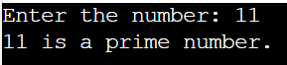

c) Even or Odd.

Codes:

#include <stdio.h>

int main()

{

int num,i,flag=1;

printf("enter your number:");

scanf("%d",&num);

if(num%2==0){

printf("Number is even");

}

else{

printf("Number is odd");

}

return 0;

}

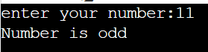

**3.** Make a program in C to accept monthly electricity consumed unit from user. Find out total monthly electricity charge of a customer as per below given condition.

Criteria of unit charge electricity:

Unit (1 to 100) = Rs. 5 (per unit)

Unit (101 to 200) = Rs. 10 (per unit)

Unit (201 to 300) = Rs. 15(per unit)

Unit (>300) = Rs. 20(per unit)

Tax: 5% of electricity charge.

So, Total electricity charge will be = total unit bill + Tax.

Codes:

#include <stdio.h>

int main()

{

int unit;

float amt,total_amt,tax;

scanf("%d",&unit);

if(unit<=100){

amt=unit*5;

}

else if(unit<=200){

amt=500+((unit-100)*10);

}

else if(unit<=300){

amt=1500+((unit-200)*15);

}

else{

amt=3000+((unit-300)*20);

}

tax=amt*0.05;

total_amt=amt+tax;

printf("Electricity Bill = Rs. %.2f", total_amt);

return 0;

}

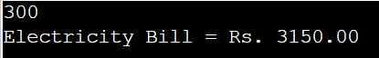

**4.** Make a program in C to accept basic salary from user. Find out net salary of an employee as per following condition

DA: 12% of Basic salary

HRA: 30% of Basic salary

Others: Rs.1000 (monthly fix)

PF :12% of Basic salary

Gross Salary: (Basic Salary + DA + HRA) - PF

MA: 5% of basic salary

Net Salary = Gross Salary – MA

Codes:

#include <stdio.h>

int main()

{

float bs,da,hra,pf,gs,ma,ns;

printf("Basic Salary:");

scanf("%f",&bs);

da=(0.12*bs);

hra=(0.30*bs);

pf=0.12*bs;

gs=(bs+da+hra)-pf;

ma=(0.05*bs);

ns=gs-ma;

printf("DA: %.2f",da);

printf("\nHRA: %.2f",hra);

printf("\nothers= RS. 1000(monthly fix)");

printf("\nPF: %.2f",pf);

printf("\nGross Salary: %.2f",gs);

printf("\nMA:%f",ma);

printf("\nNet Salary= %.2f",ns);

return 0;

}

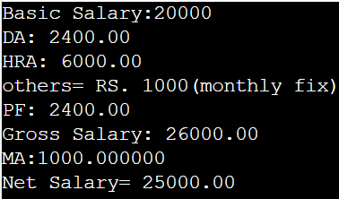

**5.** Make a program in C to accept one five-digit number from user. Find out multiplication and addition of alternate digit.

input: 56789

output:

multiplication=315

addition = 21

Codes: